BEACON COLLABORATIVE
Chicago Food Access Pilot
Surplus Food Redistribution Network —Analytics Report
UN SDG Goal 2 — Zero Hunger

Prepared by: Team Beacon Collaborative
Programme: Grow with Google Capstone Showcase, 2026
Date: 27 July 2026
Live interactive dashboard: Chicago Food Access Dashboard (Tableau Public)

Executive Summary
Beacon Collaborative is designing a surplus food redistribution network to connect grocery vendors dumping unsold perishable inventory with local pantries serving food-insecure households, in support of UN SDG Goal 2 (Zero Hunger). This report documents the full analytics process behind selecting and scoping Chicago, Illinois as the pilot region, and presents the resulting dataset, findings, dashboard, and recommendations.
Chicago was selected because its need is large and well-documented (roughly 1 in 4 metro-area residents food-insecure, pantry visits up 48% since 2020), its legal environment protects good-faith donors, and its data infrastructure allowed the team to build a real, evidence-based, geocoded dataset rather than relying on assumption. The analysis combines official City of Chicago demographic data, community reporting on food deserts and grocery closures, and live-collected grocery store and food pantry locations into a single, cleaned, analysis-ready master table of 45 real locations across six priority community areas.
The single most actionable finding is that West Garfield Park — the sample's third-highest-hardship area has five grocery stores but zero food pantries in the current dataset, making it the clearest, most defensible starting point for a pilot. Auburn Gresham and Austin show the lowest grocery density relative to their populations, representing a scale problem rather than a total-absence problem. Across the sample, pantries that do coexist with a grocery store sit close to one (0.53 miles on average), indicating the core gap is the absence of coverage, not the distance between existing points.
These findings are now live in a published Tableau dashboard, alongside a defined set of KPIs (grocery/pantry density, pantry-to-grocery ratio, a composite Food Access Gap Score) that the team can track as the pilot progresses. The report closes with concrete business recommendations, a transparent account of the study's limitations — most notably that 4 of the original 10 priority areas still lack location-level data — and a prioritized plan for future work.
Table of Contents
Executive Summary 1
1. Introduction 3
2. Problem Grounding 3
3. Research Objectives 3
4. Research Questions 3
5. Data Sources 4
6. Data Collection 4
7. Data Cleaning 4
7.1 Initial cleaning pass 4
7.2 Second-pass data-quality review 5
8. Variable Selection 5
9. Data Dictionary 6
10. Data Model 7
11. Exploratory Data Analysis 8
11.1 Dataset overview 8
11.2 Community area profile 8
11.3 Grocery vs. pantry coverage 8
11.4 Distance from pantries to the nearest grocery store 9
11.5 Household income vs. hardship index 9
12. Key Findings 11
13. KPI Definitions 12
14. Dashboard Design 13
14.1 View 1 — Chicago Food Access Map 13
14.2 View 2 — Community Need & Hardship 13
14.3 View 3 — Coverage Gap Analysis 13
15. Business Recommendations 14
16. Why Chicago 15
17. Limitations 15
18. Future Work 15
References 16
Appendix 17
Appendix A — Data File Inventory 17
Appendix B — Full Data Cleaning & Correction Log 17
Appendix C — Priority Area Ranking (All 10 Originally Identified Areas) 17

1. Introduction
Team Beacon Collaborative was assigned Goal 2 (Zero Hunger) of the UN Sustainable Development Goals, with the brief: local grocery vendors dump surplus perishable items due to a lack of an automated, hyperlocal coordination hub for local pantries. The team's task is to design a Surplus Food Redistribution Network that connects vendors with pantries in real time, and to ground that design in real data rather than assumption.
This report is the final, consolidated analytics deliverable for the project's Chicago pilot. It brings together the team's problem research, regional scope analysis, dataset construction, exploratory analysis, and dashboard work into a single document, structured to take a reader from the original problem statement through to a specific, data-backed recommendation for where and how to launch.

2. Problem Grounding

Global food-waste research consistently shows that perishables: fresh produce, dairy, meat, seafood, and bakery items, make up the large majority of surplus food, precisely because they cannot simply sit on a shelf. The UNEP Food Waste Index Report 2024 estimates 1.05 billion tonnes of food wasted globally in 2022, while FAO's State of Food Security and Nutrition in the World (SOFI) 2025 estimates roughly 673 million people faced hunger in 2024, with 2.3 billion experiencing moderate or severe food insecurity.
The core mechanism behind this paradox is time: perishable surplus is only safe to redistribute for a narrow window (food-safety guidance defines a 2-hour "danger zone" outside refrigeration), and without a fast, automated way to match a vendor's surplus to a nearby pantry within that window, disposal becomes the default. Chicago mirrors this problem at local scale: roughly 25% of the metro area faces food insecurity, pantry visits are up 48% since 2020, and specific community areas have lost grocery access entirely in recent years (Whole Foods in Englewood, 2022; four Walmart locations citywide, 2023; Aldi locations in West Garfield Park and Auburn Gresham). This report treats Chicago's documented, geographically concentrated need as the ground truth the rest of the analysis is built on.

3. Research Objectives

- Quantify the scale and geographic concentration of food insecurity and food access gaps across Chicago's highest-need community areas.
- Identify specific, named, geocoded grocery vendors and food pantries suitable for a pilot coordination network.
- Build a clean, reusable, analysis-ready dataset and a published dashboard that the team can use to monitor and prioritize the pilot going forward.
- Produce a defensible, evidence-based recommendation for where and how Beacon Collaborative should launch its first pilot.

4. Research Questions

- Which Chicago community areas show the strongest combination of socioeconomic hardship and food access gaps?
- How well do existing grocery stores and food pantries cover these high-need areas, and where are the largest coverage gaps?
- What is the physical distance between food pantries and their nearest grocery store, and does this distance meaningfully vary by area?
- Which organizations (e.g., Chicago Food Rescue, Greater Chicago Food Depository) already operate in these areas, and where do genuine gaps remain?
- What KPIs and dashboard views would let the team track need, coverage, and pilot progress on an ongoing basis?

5. Data Sources

Data category | Source | What was collected
Demographics | City of Chicago Data Portal — Selected Socioeconomic Indicators (2008-2012); Wikipedia community-area infoboxes (2023 population, median household income); Point2Homes/places.us.com (median age) | Population, poverty rate, household income, hardship index, median age (partial)
Food access | Team research on documented grocery closures and food-desert designations (Chicago Sun-Times, Block Club Chicago, Next City, WBEZ, 2022-2025) | Food desert flag, issue type, derived low-income flag
Food insecurity | Greater Chicagoland Hunger Report 2025 (GCFD / Northern Illinois Food Bank / Food Bank of NW Indiana); Feeding America Map the Meal Gap | Citywide food-insecurity rate, meal-gap reference
Grocery stores | Live Google Places search, 19 July 2026 | 26 named stores after duplicate correction: name, address, coordinates, rating, phone, category
Food pantries | Live Google Places search, 19 July 2026 | 19 named organizations: name, address, coordinates, rating, phone, category

6. Data Collection

- Community-area socioeconomic indicators were pulled for all 77 official Chicago community areas, giving full citywide coverage for demographic and hardship variables.
- Grocery-store and food-pantry location data were collected via targeted Google Places queries for six of the ten priority community areas identified earlier in region-and-scope research: Englewood, Austin, West Garfield Park, Auburn Gresham, North Lawndale, and South Lawndale (Little Village).
- Population, median household income, and hardship index for the ten priority areas were individually verified against each community area's Wikipedia infobox and the City of Chicago socioeconomic dataset.
- Food-insecurity rate and meal-gap figures were sourced at the metro/county level, since no public dataset publishes these at the Chicago community-area level — this scope limit is carried through the entire analysis and flagged wherever it applies.
Coverage note: four of the ten priority areas (East Garfield Park, Kenwood, Lake View, Chatham) currently have demographic context on file but no grocery/pantry location rows, location data collection for those four areas is the top recommended item.

7. Data Cleaning

The raw datasets (46 rows: 26 grocery stores + 19 food pantries) went through a documented cleaning pass before analysis, followed by a second pass data-quality review that identified and corrected one duplicate. The full step by step log is reproduced in Appendix B.

7.1 Initial cleaning pass

- Added a stable row_id primary key in the format CHI-XXX (e.g., CHI-001, CHI-002, …) so every row can be uniquely referenced across joins and dashboards.
- Stripped leading/trailing whitespace from every text field.
- Reclassified the one region-wide row (Greater Chicago Food Depository headquarters) from a blank community_area to an explicit label, so it is never mistaken for a missing value.
- Filled 6 missing phone_number values with an explicit 'Not listed' label rather than leaving them blank.
- Standardized numeric precision across coordinates, population, income, hardship index, food-insecure estimate, and rating count.
- Converted flag fields from floating point to proper 0/1 integers.
- Validated every coordinate against Chicago's bounding box — 0 rows fell outside it.
- Checked for duplicate locations by exact name + address match — 0 duplicates found at that pass.
- Left distance to nearest supermarket miles as a true null (not zero) for all grocery store rows, since the metric only applies to pantries.

7.2 Second pass data-quality review

A follow-up review checked duplicates by Google place_id a stricter test than name+address matching, since it catches the same physical business listed under two different names. This surfaced one true duplicate: a single store (place_id ChIJrwMvieMuDogRmh1myjJXeYs) had been pulled into the dataset twice, once as "WIC Grocery" and once as "Save A Lot (Halsted)", from two separate neighborhood searches, and mistagged to two different community areas (Englewood and Auburn Gresham).
The store's address (6202 S Halsted St, at W 62nd St) was verified against Chicago's community area boundaries and falls within Englewood, not Auburn Gresham. The duplicate row was removed; the surviving row was corrected to location_name "Save A Lot (Halsted)", category "discount grocery" (matching the business's actual chain identity), and community area "Englewood". The dataset was re-validated afterward: zero duplicate row_id, zero duplicate place_id, zero duplicate name + address, and internal consistency confirmed, every row sharing a community_area still carries identical demographic values.
Note on row_id continuity: the removed row's identifier (CHI-011) is now retired rather than reused — the remaining IDs are renumbered.
Result: chicago_datasets.csv contains 45 rows (26 grocery stores + 19 food pantries) with 24 consistently-typed columns, zero duplicate locations, zero out-of-bounds coordinates, and every null value either justified or explicitly labeled.

8. Variable Selection

Every variable in the master table was chosen because it directly serves one of the five research questions in Section 4, not simply because it was available:
- population_2023, poverty_rate_pct, household_income_usd, hardship_index — answer Research Question 1 (where is need concentrated) and normalize raw counts into fair per-capita comparisons across areas of very different size.
- food_desert_flag, food_access_issue_type, low_income_flag, answer Research Question 1 by flagging areas with a documented, citable food-access problem rather than relying on hardship index alone.
- location_type, location_name, address, latitude, longitude, category — answer Research Question 2 (coverage) by identifying and mapping every real store and pantry the team can act on.
- distance_to_nearest_supermarket_miles — directly answers Research Question 3 (physical distance) using the dataset's own coordinates.
- google_rating, google_rating_count — a light-touch proxy for community trust and traffic, useful for weighing which locations are likely highest-impact partners.
- food_insecurity_rate_pct_citywide_estimate, food_insecure_population_est — retained despite their citywide (not area-level) granularity, because Research Question 1 still needs some estimate of absolute need, clearly labeled as an estimate rather than a precise local measurement.
Variables considered but excluded: pantry capacity, hours of operation, and existing-partnership status (relevant to Research Question 4) were identified as valuable but were not obtainable from any public dataset — they require direct outreach and are flagged as Future Work rather than fabricated. A meal_gap_note text column (a pointer to Feeding America's county-level Meal Gap tool) was included in the original build but subsequently dropped from the master table during team review, since it carried no computed value and was identical on every row — the same guidance is preserved here in Section 18 instead.

9. Data Dictionary

The full data dictionary ships as its own file (data_dictionary.csv) with a row for every column, its type, source, and known limitations.

Column | Type | Description
community_area | string | Chicago community area (or 'Regional' for citywide partners)
location_type | string | grocery_store or food_pantry
location_name / address / latitude / longitude | string / float | Identity and geolocation of the store or pantry
population_2023 | integer | Community area population, 2023 estimate
median_age | float | Median age (available for 4 of 10 priority areas)
poverty_rate_pct | float | % households below the federal poverty line
household_income_usd | integer | Median household income, USD
hardship_index | integer | Composite hardship score, 1 (least) to 100 (most)
food_desert_flag / food_access_issue_type | 0/1, string | Documented food-desert designation or recent grocery closure
low_income_flag | 0/1 | 1 if area poverty_rate_pct exceeds the citywide average (19.7%)
distance_to_nearest_supermarket_miles | float | Pantry-to-nearest-grocery distance (null for store rows)
food_insecurity_rate_pct_citywide_estimate | float | Citywide estimate (25%) applied uniformly — not area-measured
food_insecure_population_est | integer | population_2023 × 25% — an estimate, not a direct measurement
google_rating / google_rating_count / phone_number / place_id / category | mixed | Location metadata from Google Places

10. Data Model

The delivered dataset (chicago_datasets.csv) is intentionally a single, flat, denormalized table, one row per grocery store or food pantry, with its community area's demographic and food-access context repeated on every row. This is the right shape for Tableau, where a flat table minimizes join complexity for a small team.
Conceptually, the same information can be modeled as two related tables — a dimension table for community-area context and a fact table for individual locations — which clarifies the grain of the data and would be the natural next step if the dataset moves into a relational database:
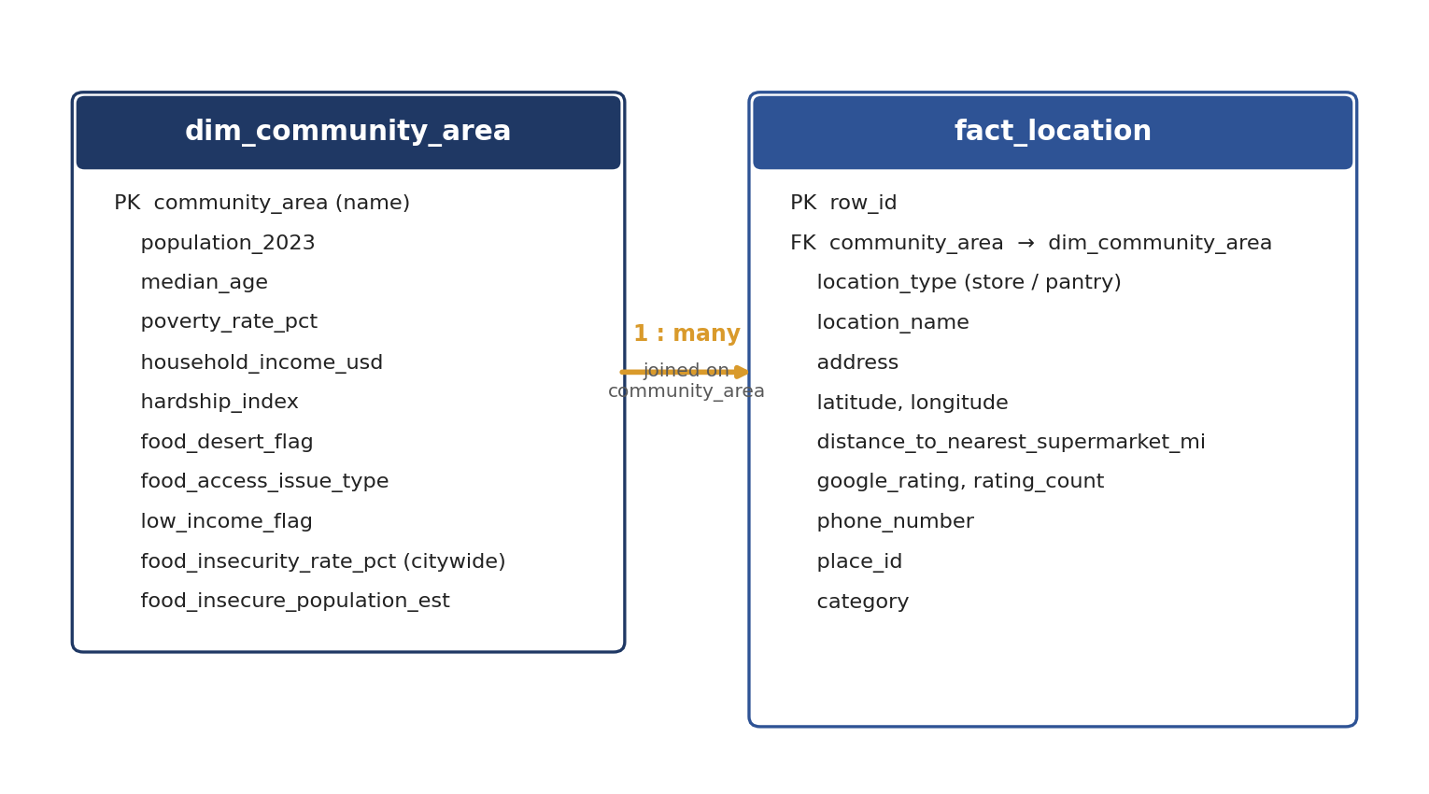
Figure 0. Conceptual data model — a community-area dimension table joined 1-to-many to a location fact table.
dim_community_area holds one row per community area (10 rows in the current priority list; extendable to all 77). fact_location holds one row per physical location (45 rows currently, after the duplicate correction) and references its community area by name. The flat master table used for analysis is the result of joining these two conceptual tables together — it can be split back into this two-table form at any time without losing information. Enforcing a uniqueness constraint on place_id in fact_location — as a relational database naturally would — is exactly the check that would have caught the duplicate store described in Section 7.2 automatically.

11. Exploratory Data Analysis

11.1 Dataset overview

- 45 total locations: 26 grocery stores and 19 food pantries across 6 Chicago community areas.
- Grocery store mix: 15 independent grocers, 4 discount grocers, 3 supermarket chains, plus 1 each of specialty meat, community market, convenience store, and wholesale grocery.
- Pantry mix: 9 food pantries, 4 food distribution centers, 4 community organizations, 1 community service center, and 1 regional food bank (GCFD headquarters).

11.2 Community area profile

Area | Population | Poverty rate | Household income | Hardship idx | Food-insecure est. | Groceries | Pantries | Grocery/10k | Pantry/10k | Pantry:Grocery
South Lawndale | 68,798 | 30.7% | $42,010 | 96 | 17,200 | 3 | 5 | 0.44 | 0.73 | 1.67
Englewood | 21,411 | 46.6% | $22,228 | 94 | 5,353 | 10 | 6 | 4.67 | 2.80 | 0.60
West Garfield Park | 17,433 | 41.7% | $29,443 | 92 | 4,358 | 5 | 0 | 2.87 | 0.00 | 0.00
North Lawndale | 31,244 | 43.1% | $37,247 | 87 | 7,811 | 4 | 3 | 1.28 | 0.96 | 0.75
Auburn Gresham | 45,049 | 27.6% | $37,741 | 74 | 11,262 | 1 | 1 | 0.22 | 0.22 | 1.00
Austin | 98,882 | 28.6% | $44,883 | 73 | 24,720 | 3 | 3 | 0.30 | 0.30 | 1.00
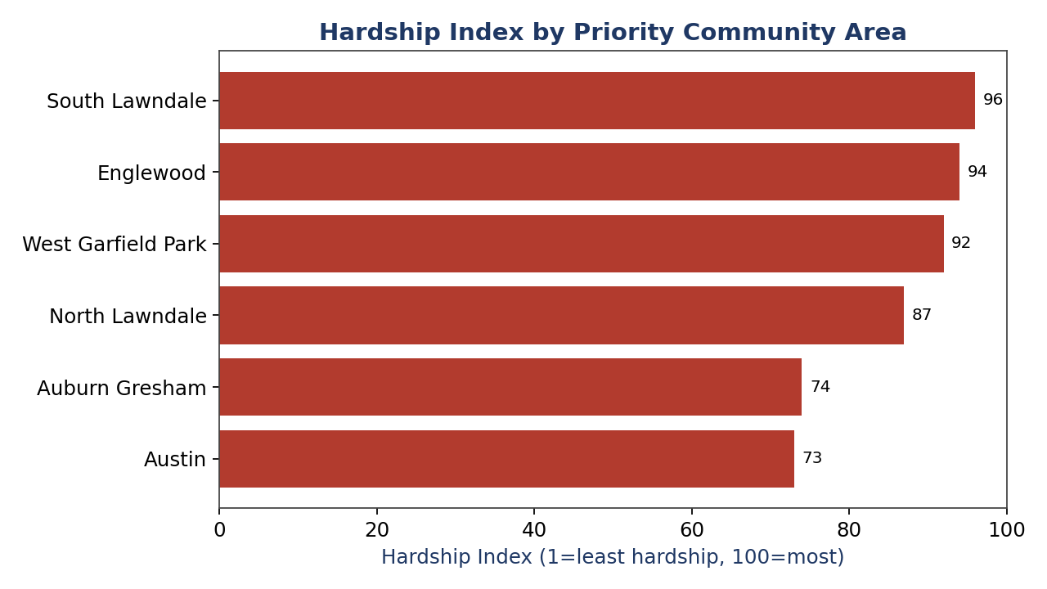
Figure 1. Hardship Index by priority community area (South Lawndale highest at 96; Austin lowest at 73).

11.3 Grocery vs. pantry coverage
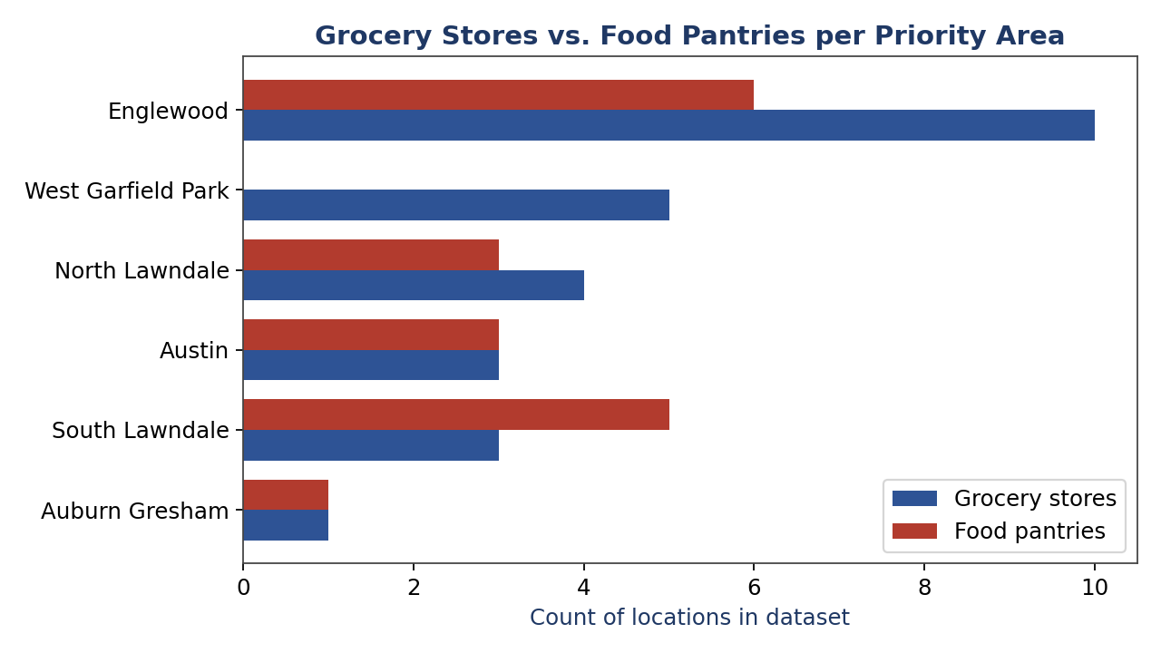
Figure 2. Count of grocery stores vs. food pantries collected per area. West Garfield Park shows 5 grocery stores but zero pantries; Auburn Gresham now shows the smallest total footprint (1 store, 1 pantry) after the duplicate correction.

11.4 Distance from pantries to the nearest grocery store

Across the 19 pantries with a computed distance, the average straight-line distance to the nearest grocery store in this dataset
is 0.53 miles (median 0.49, range 0.03-1.52 miles), unchanged by the duplicate correction, since the removed row shared its location with a retained row.
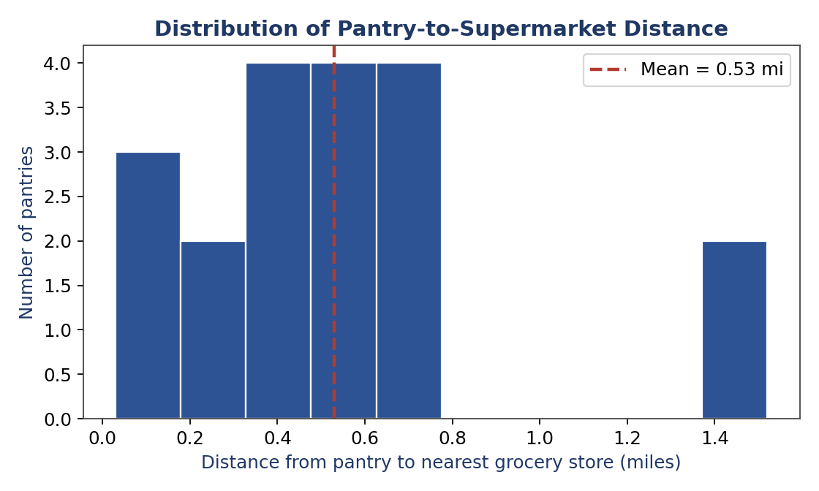
Figure 3. Distribution of pantry-to-nearest-supermarket distance (miles).

11.5 Household income vs. hardship index

Auburn Gresham and Austin show similar hardship scores (74 and 73) despite a meaningful income gap ($37,741 vs. $44,883), suggesting hardship in this sample is driven by more than income alone.
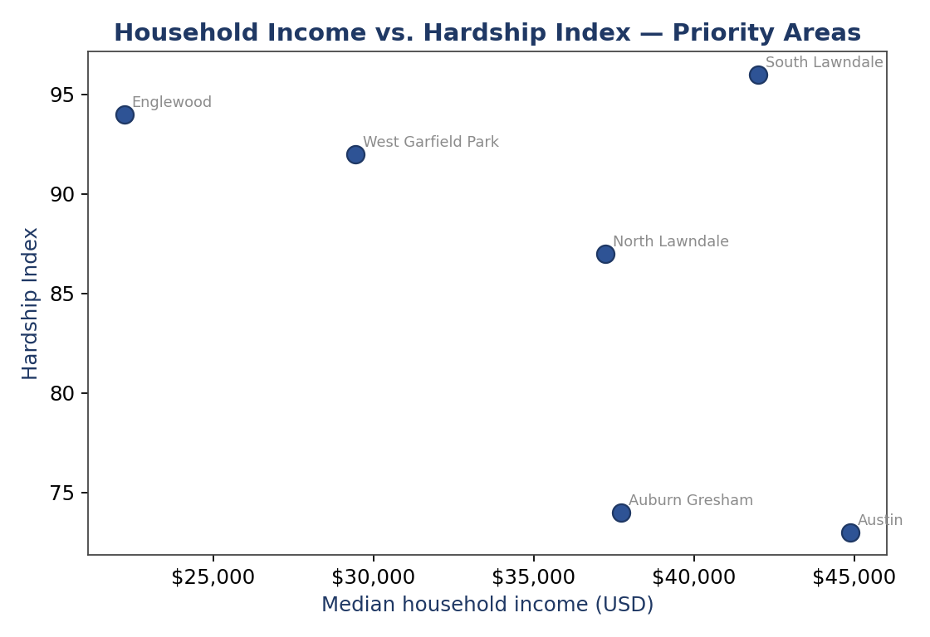
Figure 4. Household income vs. hardship index across the six sampled priority areas.

12. Key Findings

- South Lawndale (96), Englewood (94), and West Garfield Park (92) carry the three highest hardship scores in the sample, confirming the earlier region-scope recommendation to prioritize these areas first.
- West Garfield Park has the clearest coverage gap in the current data: 5 grocery stores, zero food pantries, despite the second-highest hardship index in the sample. This is the single strongest, most actionable finding in the dataset, and it is unaffected by the duplicate correction.
- Auburn Gresham now shows the lowest grocery density per 10,000 residents in the sample (0.22, down from 0.44 before the duplicate correction), with Austin close behind (0.30) — both a scale problem distinct from West Garfield Park's complete-absence problem.
- Where a pantry and a grocery store do coexist, they tend to be close together (average 0.53 miles) — distance is not the main bottleneck where both already exist.
- South Lawndale has the strongest pantry-to-grocery ratio in the sample (1.67), suggesting a comparatively well-organized recipient network already in place there.
- The weak correlation (r = -0.19) between hardship index and pantry-to-supermarket distance means distance alone should not be used to prioritize areas — a composite measure (Section 13) is a better prioritization tool.
- Food pantries in the sample carry a slightly higher average public rating (4.43) than grocery stores (4.11), a mild signal of strong community trust in existing pantry operations.
- Four of the ten originally identified priority areas have no location-level data yet — current findings are based on 6 of 10 priority areas.

13. KPI Definitions

Ready-to-paste Tableau calculated-field formulas for every KPI used in the dashboard:
KPI / Calculated field | Tableau formula | Category | Why it matters
Grocery Density per 10k | ([Grocery Store Count] / [Population 2023]) * 10000 | Grocery access | Stores per 10,000 residents — comparability across areas of very different population size
Pantry Density per 10k | ([Food Pantry Count] / [Population 2023]) * 10000 | Pantry access | Pantries per 10,000 residents
Pantry-to-Grocery Ratio | [Food Pantry Count] / [Grocery Store Count] | Coverage balance | How well pantry capacity tracks retail grocery presence in the same area
% Population Food-Insecure (Est.) | [Food Insecure Population Est.] / [Population 2023] | Need intensity | Share of an area's population estimated food-insecure (citywide-rate proxy)
Avg. Distance to Supermarket (LOD) | { FIXED [Community Area] : AVG([Distance to Nearest Supermarket Miles]) } | Physical access | Area-level average pantry-to-nearest-grocery distance, independent of view-level filters
Underserved Priority Flag | IF [Hardship Index] >= 70 AND [Grocery Density per 10k] < WINDOW_MEDIAN([Grocery Density per 10k]) THEN 'Priority' ELSE 'Standard' END | Prioritization | Flags high-hardship, low-grocery-density areas as pilot-priority
Food Access Gap Score | ([Hardship Index] * 0.6) + ((1 - ([Grocery Density per 10k] / WINDOW_MAX([Grocery Density per 10k]))) * 40) | Composite KPI | 0-100 composite score blending socioeconomic hardship with relative grocery scarcity; higher = greater need for intervention
Vendor Recruitment Target Count | COUNTD( IF [Location Type] = 'grocery_store' THEN [Location Name] END ) | Operational KPI | Running count of unique donor vendors identified per area, tracked against a recruitment goal

14. Dashboard Design

The team has published the working dashboard to Tableau Public, built from chicago_datasets.csv:

Chicago Food Access Dashboard — public.tableau.com/views/BeaconCollaborative-ChicagoFoodAccessPilot/ChicagoFoodAccessDashboard

It comprises three views, each using a shared community_area filter/action so clicking any area updates every other view.

14.1 View 1 — Chicago Food Access Map

- Symbol map with Latitude/Longitude, colored and shaped by location_type (grocery_store = green square, food_pantry = orange circle).
- Pantry markers sized by google_rating_count; tooltip shows name, address, category, rating, and distance to nearest supermarket.
- Filters: community_area, location_type, category, food_desert_flag.

14.2 View 2 — Community Need & Hardship

- KPI cards: Average Hardship Index, Total Estimated Food-Insecure Population, Areas With Zero Pantries, Citywide Food Insecurity Rate.
- Bar chart of Hardship Index by area, colored by the Underserved Priority Flag; scatter of Household Income vs. Hardship Index.

14.3 View 3 — Coverage Gap Analysis

- Dual bar chart of Grocery vs. Pantry counts, sorted by Food Access Gap Score.
- Quadrant scatter (Hardship Index vs. Grocery Density per 10k) flagging West Garfield Park, Auburn Gresham, and
- Austin as the priority-recruitment zone.
- Ranked list by Food Access Gap Score with a running Vendor Recruitment Target Count.

15. Business Recommendations

- Launch the pilot first in West Garfield Park: it combines a high hardship score (92) with the sample's only complete pantry gap (0 of 5 candidate stores currently paired with a pantry) — the clearest, most defensible starting point.
- Prioritize independent and discount grocers (Save A Lot, Aldi, independents) for first outreach — these are the vendor types most likely to lack an existing MealConnect or Chicago Food Rescue relationship.
- Position the platform as complementary to Chicago Food Rescue and the Greater Chicago Food Depository, not competitive — open a direct conversation with both to confirm this pilot's target vendors/pantries are not already in their active networks.
- Sequence expansion into Auburn Gresham and Austin next, using the Food Access Gap Score to rank order — these areas need scale (more stores/pantries relative to population) rather than closing a total-absence gap.
- Track the defined KPIs monthly via the published Tableau dashboard, both to guide internal prioritization and to support grant or partner reporting with a clean, consistent set of numbers — and refresh the dashboard's data extract promptly whenever the source dataset changes, as described in Section 14.

16. Why Chicago

- Scale of need is real and well-documented: roughly 1 in 4 people in the metro area face food insecurity, and pantry visits are up 48% since 2020.
- The problem is geographically concentrated, not diffuse: 26 of 77 community areas carry ≥25% food insecurity, heavily overlapping the six areas this dataset already covers.
- Legal risk is low: the federal Bill Emerson Act and Illinois' own Good Samaritan food-donation law both protect good-faith donors.
- Data infrastructure is strong: the City of Chicago's open data portal, Wikipedia-documented community-area statistics, and dense Google Places coverage made it possible to build a real, evidence-based pilot dataset quickly and to catch and correct a data-quality issue before it reached external stakeholders.
- The competitive landscape is known, not a blind spot: Chicago Food Rescue and the Greater Chicago Food Depository already operate here, letting the team design this pilot to complement their coverage gaps rather than duplicate a proven model from scratch.

Bottom line: Chicago is not simply a convenient default — it is the region where this team's specific evidence (hardship index, coverage gaps, legal protections, and known competitors) lines up most cleanly with a pilot a small student team can realistically execute and measure.

17. Limitations

- Location data currently covers 6 of the 10 priority community areas — East Garfield Park, Kenwood, Lake View, and Chatham still need grocery/pantry data collected.
- Food insecurity rate and meal gap are citywide/county estimates, not area-measured figures — do not present food_insecure_population_est as a precise headcount.
- Median age is missing for 6 of 10 areas; no official community-area-level source was found within this project's scope.
- The grocery-store sample (26 stores) is not an exhaustive census — cross-reference against the Chicago Data Portal's Food Inspections dataset (16,000+ establishments) before finalizing vendor outreach.
- Recipient-side operational detail (pantry capacity, hours, refrigeration access, existing partnership status) is not in this dataset and would require direct outreach to collect.
- This dataset has already required one duplicate correction (Section 7.2) — a full place_id uniqueness audit should be standard practice before every future data refresh, not a one-time fix.
- All figures are current as of 26 July 2026; re-validate before external presentation, especially Google ratings/counts, which drift over time.

18. Future Work

- Collect grocery-store and food-pantry location data for the remaining four priority areas (East Garfield Park, Kenwood, Lake View, Chatham).
- Cross-reference the grocery vendor list against the Chicago Data Portal's full Food Inspections dataset for a more complete donor universe.
- Pull the Cook County-specific Meal Gap figure directly from Feeding America's Map the Meal Gap tool before citing it externally.
- Conduct direct outreach to the 19 identified pantries to capture capacity, hours of operation, refrigeration access, and existing partnership status.
- Confirm with Chicago Food Rescue and GCFD which of this pilot's target vendors/pantries are not already in their active networks.
- Re-pull Google Places data closer to launch, since ratings, counts, and business status can change and re-run the place_id uniqueness check as a standard step every time.

References

- UNEP & WRAP (2024). Food Waste Index Report 2024: Think, Eat, Save. unep.org/resources/publication/food-waste-index-report-2024
- FAO, IFAD, UNICEF, WFP & WHO (2025). The State of Food Security and Nutrition in the World (SOFI) 2025. fao.org
- City of Chicago Data Portal. Census Data — Selected Socioeconomic Indicators in Chicago, 2008-2012 (kn9c-c2s2). data.cityofchicago.org
- City of Chicago Data Portal. Food Inspections dataset (4ijn-s7e5). data.cityofchicago.org
- Wikipedia. Community areas of Chicago, and individual community-area pages (Englewood, Austin, West Garfield Park, Auburn Gresham, North Lawndale, East Garfield Park, South Lawndale, Kenwood, Lake View, Chatham).
- Greater Chicago Food Depository, Northern Illinois Food Bank & Food Bank of Northwest Indiana (2025). Greater Chicagoland Hunger Report 2025. chicagosfoodbank.org
- Feeding America. Map the Meal Gap. map.feedingamerica.org
- Chicago Sun-Times / Block Club Chicago / Next City / WBEZ (2022-2025). Reporting on Chicago food deserts and grocery-store closures.
- Food Rescue Hero (2026). Chicago Food Rescue partner profile. foodrescuehero.org
- Food Rescue US. Bill Emerson Good Samaritan Food Donation Act FAQs. foodrescue.us
- USDA Food Safety and Inspection Service (FSIS). The Danger Zone (40°F-140°F). fsis.usda.gov
- Google Places API. Live location data for grocery stores and food pantries, retrieved 19 July 2026.

Appendix

Appendix A — Data File Inventory

File | Description
chicago_datasets.csv | Analysis-ready master table (45 rows, 24 columns, post-correction) — the core deliverable
data_dictionary.csv | Full column-by-column reference for the master table
chicago_community_area_socioeconomic_indicators.csv | All 77 Chicago community areas, official demographic data
chicago_food_desert_priority_areas.csv | 10 priority areas ranked by hardship index
chicago_grocery_vendor_candidates.csv / chicago_food_pantry_candidates.csv | Raw source location data (pre-correction)
chicago_hunger_regional_indicators.csv | 19 metro/citywide hunger metrics with year and source
chicago_existing_solutions_benchmark.csv | Chicago Food Rescue / GCFD / Too Good To Go comparison
eda_per_area_summary.csv | Aggregated per-area EDA output, regenerated post-correction — used in Section 11
cleaning_log.txt | Full plain-text log of the cleaning and correction steps in Section 7 (reproduced below)

Appendix B — Full Data Cleaning & Correction Log

Loaded raw master table: 46 rows, 24 columns
Stripped leading/trailing whitespace on all text fields
Labeled the GCFD regional headquarters row as 'Regional' rather than leaving community_area blank
Filled 6 missing phone_number values with 'Not listed'
Standardized numeric precision: lat/long to 6 decimals; population, income, hardship index, food-insecure estimate, and rating count cast to nullable integers
Cast food_desert_flag and low_income_flag to nullable integer (0/1) flags
Coordinate validation: 0 rows outside the expected Chicago bounding box (0 = all valid)
Duplicate location check (name + address): 0 duplicates found by exact name + address match
Saved cleaned table: chicago_datasets.csv (46 rows, 25 columns) Second-pass data quality review (25 July 2026) ---
Cross-checked duplicates by Google place_id (a stricter test than name + address matching)
Found 1 true duplicate: same physical store (place_id ChIJrwMvieMuDogRmh1myjJXeYs) had been
pulled into the dataset twice under two different names ("WIC Grocery" and "Save A Lot
(Halsted)") via two separate neighborhood searches, and mistagged to two different
community areas (Englewood and Auburn Gresham)
Verified correct community area via street address (6202 S Halsted St / W 62nd St falls
within Englewood's boundary, not Auburn Gresham's)
Removed the duplicate row (former row_id CHI-011); retained CHI-007, corrected to
location_name 'Save A Lot (Halsted)', category 'discount_grocery', community_area 'Englewood'
Re-validated: 0 duplicate row_id, 0 duplicate place_id, 0 duplicate name+address after the fix
Re-validated internal consistency: every row sharing a community_area still has identical
demographic values (population, poverty rate, income, hardship index)
Final corrected table: chicago_datasets.csv (45 rows, 24 columns)

Appendix C — Priority Area Ranking (All 10 Originally Identified Areas)

Community area | Hardship index | Documented issue | Location data collected?
South Lawndale | 96 | Grocery closure (Walmart, Little Village) | Yes
Englewood | 94 | Grocery closure (Whole Foods) | Yes
West Garfield Park | 92 | Grocery closure (Aldi) | Yes
North Lawndale | 87 | Food desert designation | Yes
East Garfield Park | 83 | Food desert designation | Not yet
Auburn Gresham | 74 | Grocery closure (Aldi) | Yes
Austin | 73 | Food desert designation | Yes
Chatham | 60 | Grocery closure (Walmart) | Not yet
Kenwood | 26 | Grocery closure (Walmart) | Not yet
Lake View | 5 | Grocery closure (Walmart) | Not yet

